**Assignment Management System**

Software Project Lab-2

User Manual Report

Group member

Tulshi Chandra Das-811

Maloy Kanti Sarker-834

Supervised by

Amit Seal Ami

Lecturer, IIT, DU



5/31/2018

#### ASSIGNMENT MANAGEMENT SYSTEM

##### SUBMITTED TO

SPL2 Committee

Institute of Information Technology

University of Dhaka

##### SUBMITTED BY

Tulshi Chandra Das BSSE0811

Maloy Kanti Sarkar BSSE0834

##### LETTER OF TRANSMITTAL

20 March 2018

The Coordinators, SPL2

Institute of Information Technology

University of Dhaka.

**Subject: Submission of term report on “Assignment Management System”**

Sir

With due respect, we are submitting the report on user manual of the above topic you assigned to us. In this report, we have given our best effort albeit some shortcomings.

We earnestly hope that you would excuse our errors and oblige thereby.

Sincerely yours

Tulshi Chandra Das BSSE0811 Supervisor

Maloy Kanti Sarkar BSSE0834

Amit Seal Ami

3rd Year, 5th Semester, 8th Batch Lecturer, IIT, DU

Institute of Information Technology

University of Dhaka

##### ACKNOWLEDGEMENT

We are highly indebted for getting such a tremendous opportunity to prepare the user manual report on Assignment Management System. We first thank to almighty god for his mercy on us to complete this project. We would like to thank our Supervisor, Amit Seal Ami, Lecturer, Institute of Information Technology, University of Dhaka, whole-heartedly, for giving us guidelines about how we can prepare this report and the coordinators of this course for giving guideline us.

##### ABSTRACT

The user manual report is made for online Assignment Management System. In this report we have given images of all steps of usage of this web application. Seeing this report one can get the concept on usage of our project. Each steps contains images with short description.

## Table of Contents

Table of Contents i

CHAPTER-01: User Manual 1

1.1 Authentication 1

1.1.1 Sign in page 1

User is an instructor 4

User is a student: 4

1.1.2 Sign Up page 5

1.1.3 forgot password 6

1.2 Student Module 8

1.2.1 Features of Student Module 9

1.3 Instructor Module 17

1.3.1 Features of Instructor Module 17

1.4 Log Out module 28

1.5 Changed requirements 29

##### 

##### Content of figures

Figure 1: Sign in Page of ASM 2

Figure 2: About part of ASM 2

Figure 3: Main Parts of help 3

Figure 4: Sub sections of Main parts of help 3

Figure 5: After log in as a student 4

Figure 6: After log in as a student 4

Figure 7: Sign up page 5

Figure 8: Welcome page 5

Figure 9: Entering mail for password recovery 6

Figure 10: Sent mail for password recovery 7

Figure 11: New password setting 7

Figure 12: Joining a group 8

Figure 13: Entering group code 8

Figure 14: Joined into a group 9

Figure 15: Menubar part of ASM for students 9

Figure 16: View groups 10

Figure 17: Calendar Page 10

Figure 18: Profile setting 11

Figure 19: Change the profile name 11

Figure 20: Classmates of student 12

Figure 21: About page of group 12

Figure 22: Joining a new group from a group 13

Figure 23: After joining the new group 13

Figure 24: Trying to submit wrong file 14

Figure 25: Wrong file submission 15

Figure 26: Selecting Zip file to submit 15

Figure 27: After right submission 16

Figure 28: View mark option 16

Figure 29: View marks 17

Figure 30:Menubar for Instructor 17

Figure 31: Group’s of teacher 18

Figure 32:Calendar page 18

Figure 33: General profile Settings 19

Figure 34: Assignment group settings 19

Figure 35: Entering information to create group 20

Figure 36 : Created a group 20

Figure 37: Group Students 21

Figure 38: About group 21

Figure 39: Post and assignment option 22

Figure 40: Enter information to post 22

Figure 41: created post 23

Figure 42: Creating assignment 23

Figure 43: Created assignment 24

Figure 44: View submission 24

Figure 45: Download assignment 25

Figure 46: assignment options 25

Figure 47: Checking plagiarism 26

Figure 48: Plagiarism checked 26

Figure 49: Check plagiarism file 27

Figure 50: give Marks 27

Figure 51: Edit assignment 28

Figure 52: Log out option 28

# CHAPTER-01: User Manual

Assignment Management System is a web application. To use this application one user must create an account. After creating account the user can join a class or create class. If the user chooses to join class he/she will be counted as a student and if the user create class he/she will be counted as an instructor in this application. If the user becomes a student he/she can submit, resubmit view marks of assignments in the group. If the user becomes an instructor he/she can post an announcement, post an assignment, edit post or assignment, delete post or assignment, give marks to students of the submitted assignment and check plagiarism of submitted assignments. The other common features such as about, support, settings also exist here.

**Users**:

* Instructor
* Student

All users have some common parts such as sign in, sign up and forgot password.

## 1.1 Authentication

### 1.1.1 Sign in page

User start with this page and if he/she is already a user he/she will sign to the website.

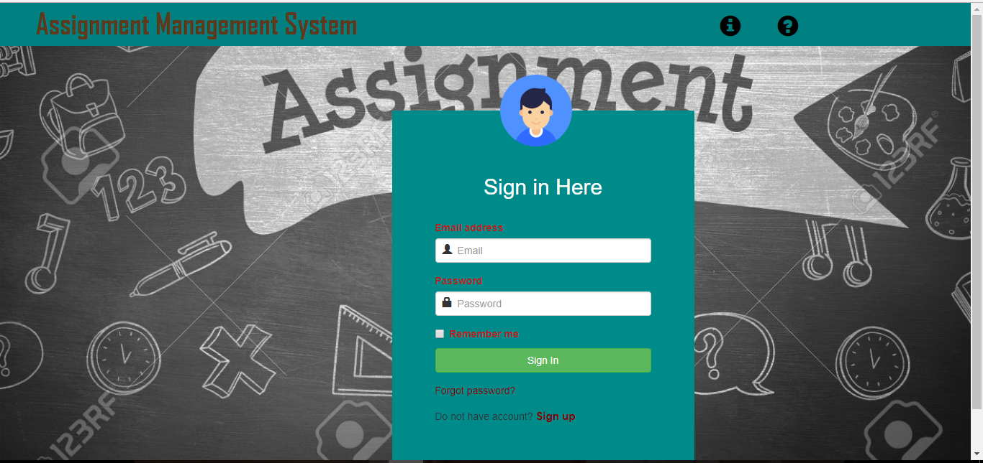

Figure 1: Sign in Page of ASM

. In the top there are about and help icon.

* About: This part describes about the developers.

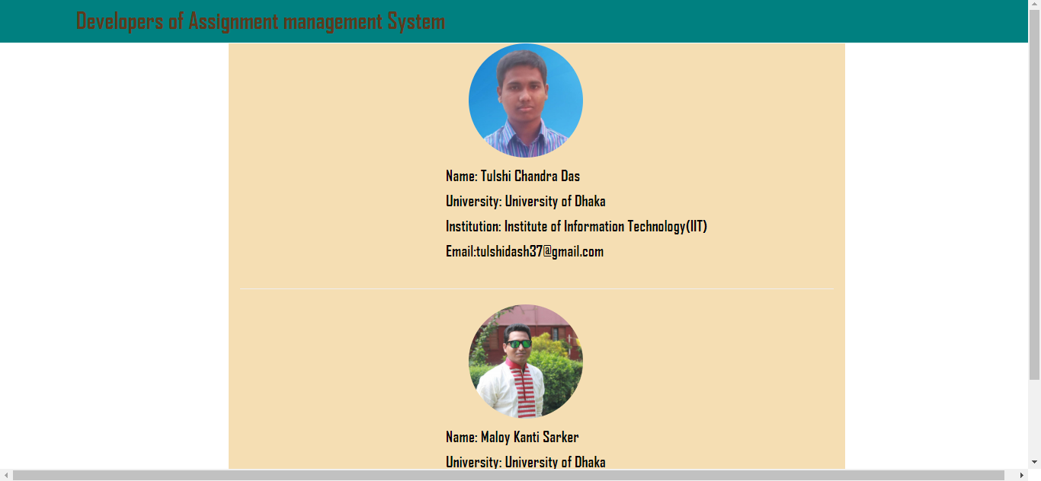

Figure 2: About part of ASM

* Help: This part describes about the website and its usages.

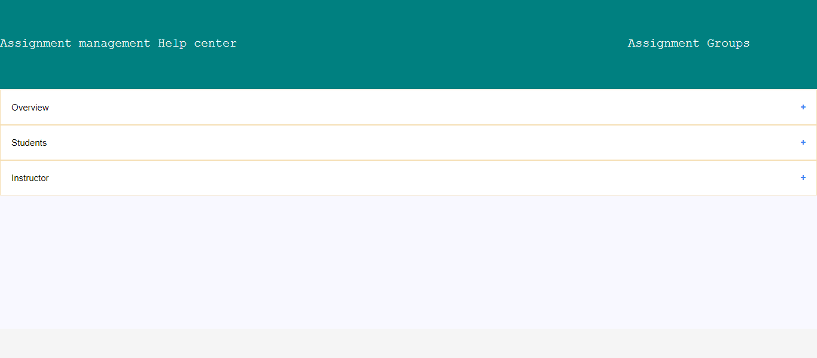

Figure 3: Main Parts of help

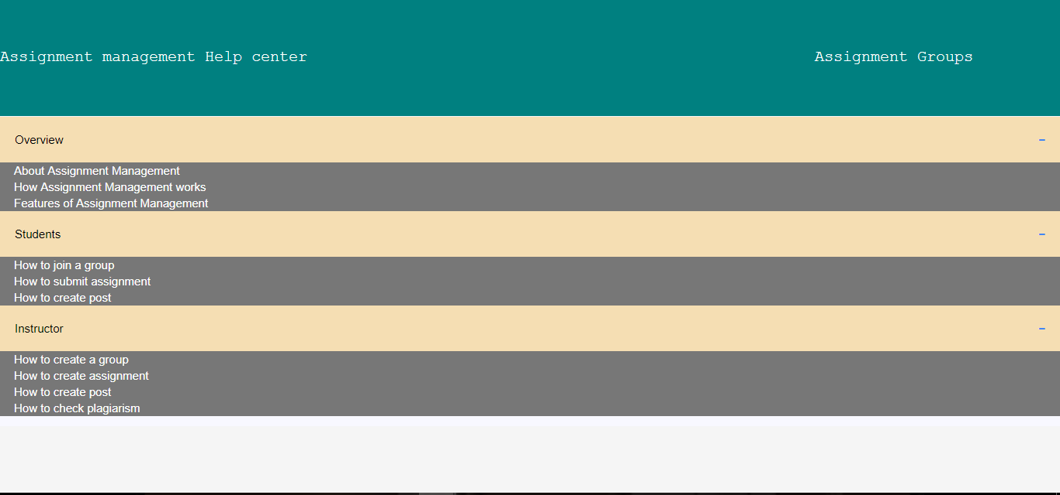

Figure 4: Sub sections of Main parts of help

### User is an instructor

After successful login:

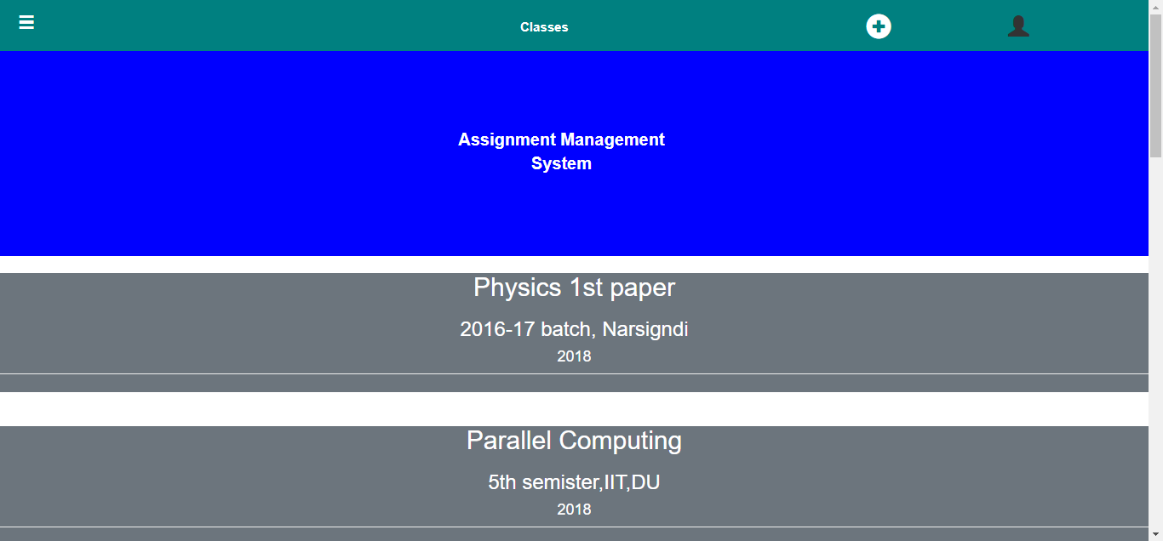

Figure 5: After log in as a student

### User is a student:

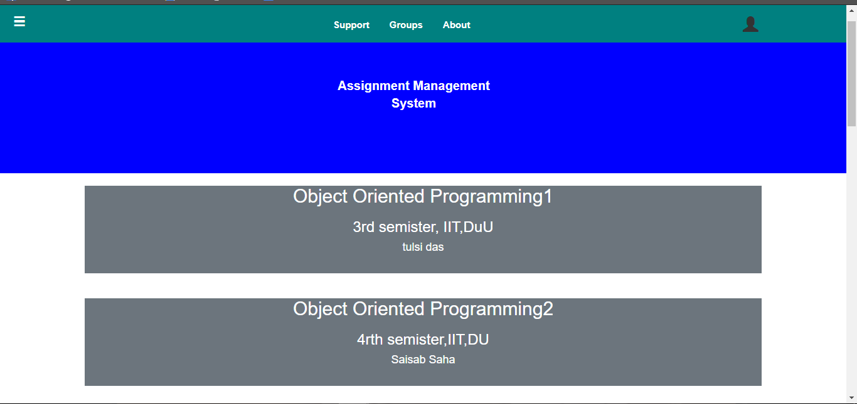

Figure 6: After log in as a student

### 1.1.2 Sign Up page

For a new user, the user will sign up to the site.



Figure 7: Sign up page

After successful sign up user will enter into the welcome page

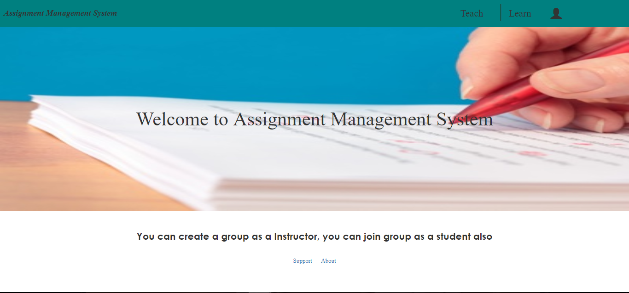

Figure 8: Welcome page

### 1.1.3 forgot password

When user will forge his password user will choose the forgot password option of the sign in page.

Then user will view the page bellow:

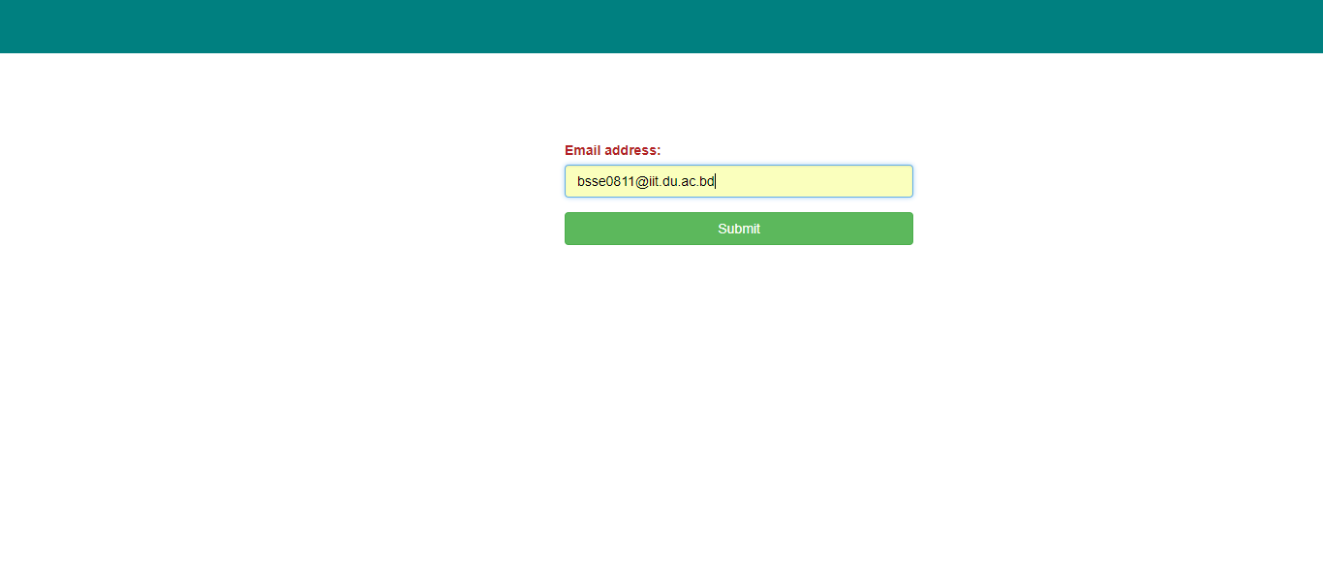

Figure 9: Entering mail for password recovery

A mail will be sent to the user’s mail address with a link. User will go to the link and reset his password.

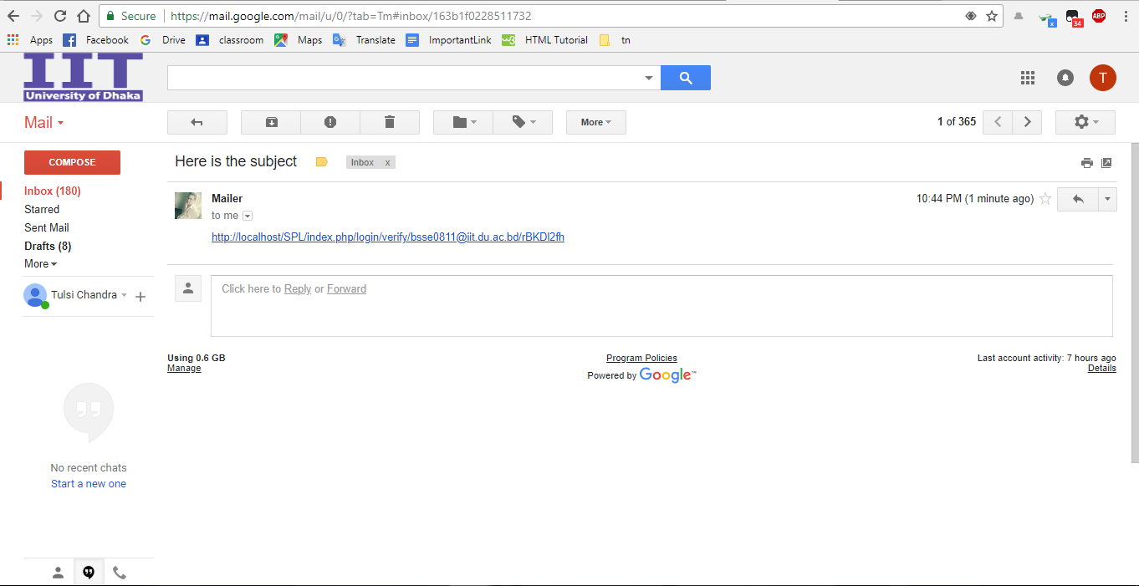

Figure 10: Sent mail for password recovery

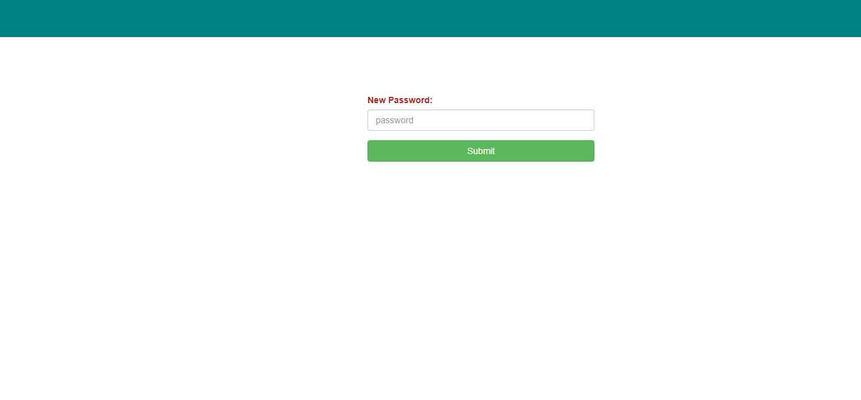

Figure 11: New password setting

## 1.2 Student Module

After creating account the user will view the welcome page and he/she will choose the learn button to join a group.

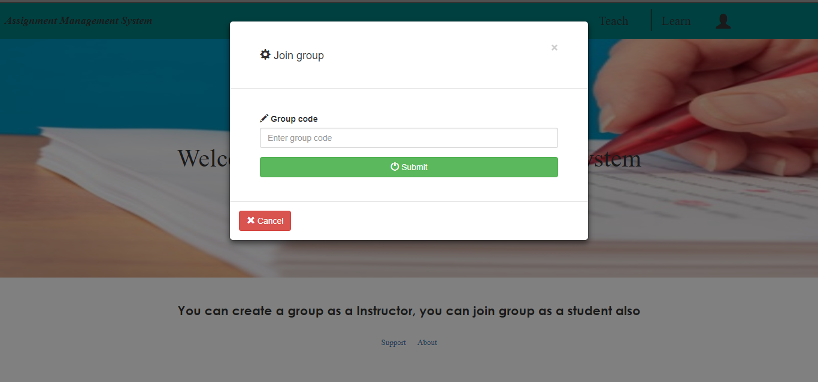

Figure 12: Joining a group

After Selecting a group code user will added to a group.

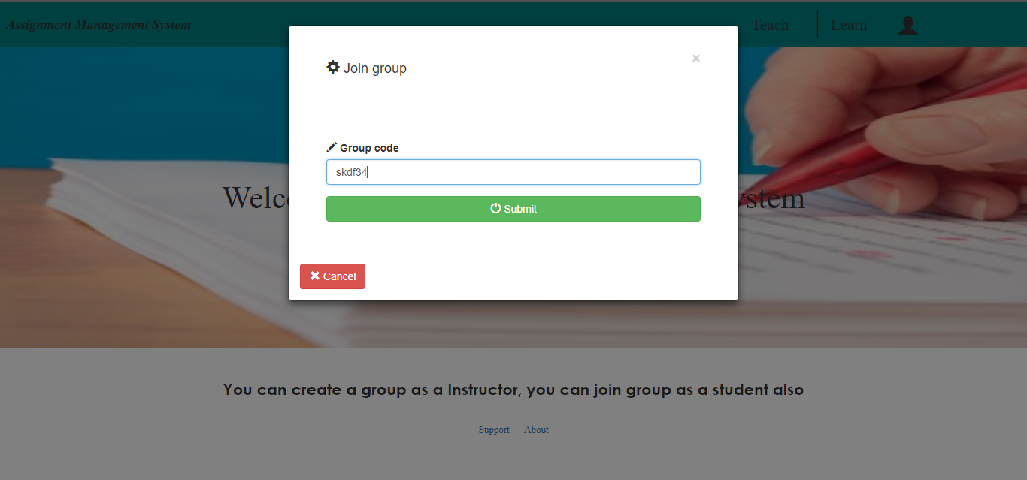

Figure 13: Entering group code

If user enter right group code s/he will joined into that group.

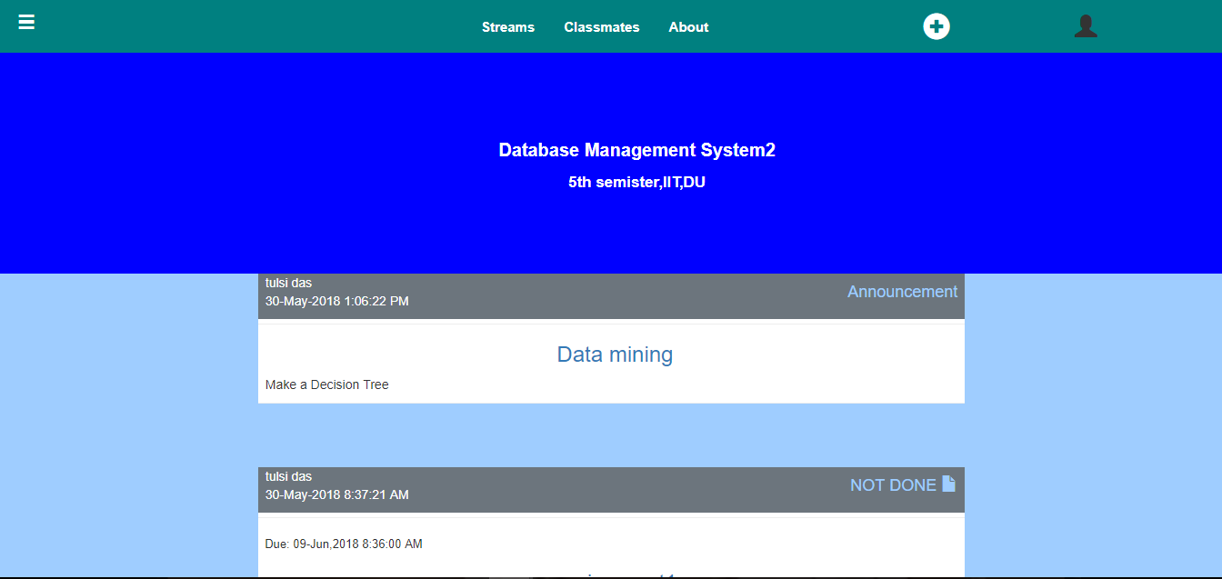

Figure 14: Joined into a group

### 1.2.1 Features of Student Module

* Menubar

In menubar button in the left side Student can see classes, calendar and settings.

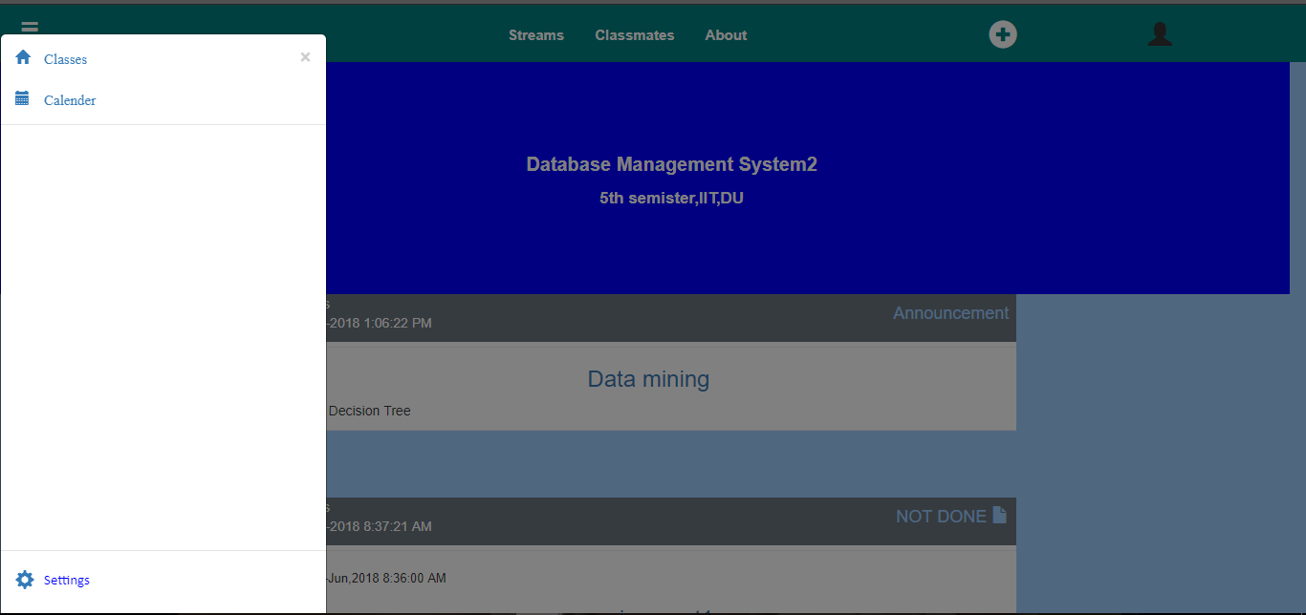

Figure 15: Menubar part of ASM for students

If the students click on classes then s/he can see the group’s name that s/he was joined .

Figure 16: View groups

If user choose the calendar option, s/he will view the calendar page.

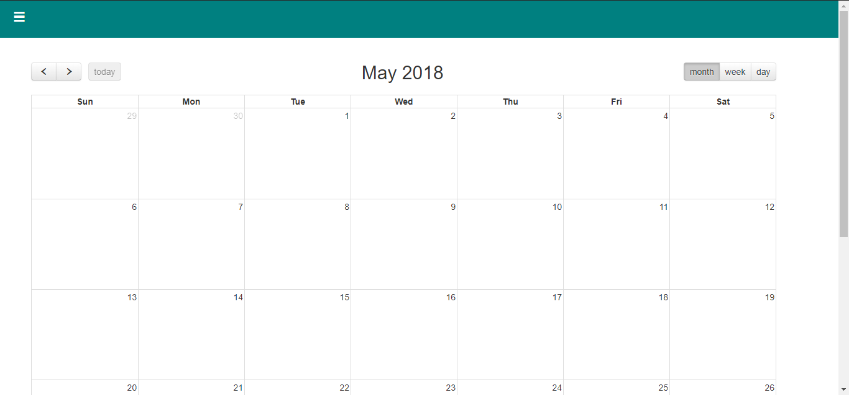

Figure 17: Calendar Page

If the user chooses the setting option s/he will view profile settings page.

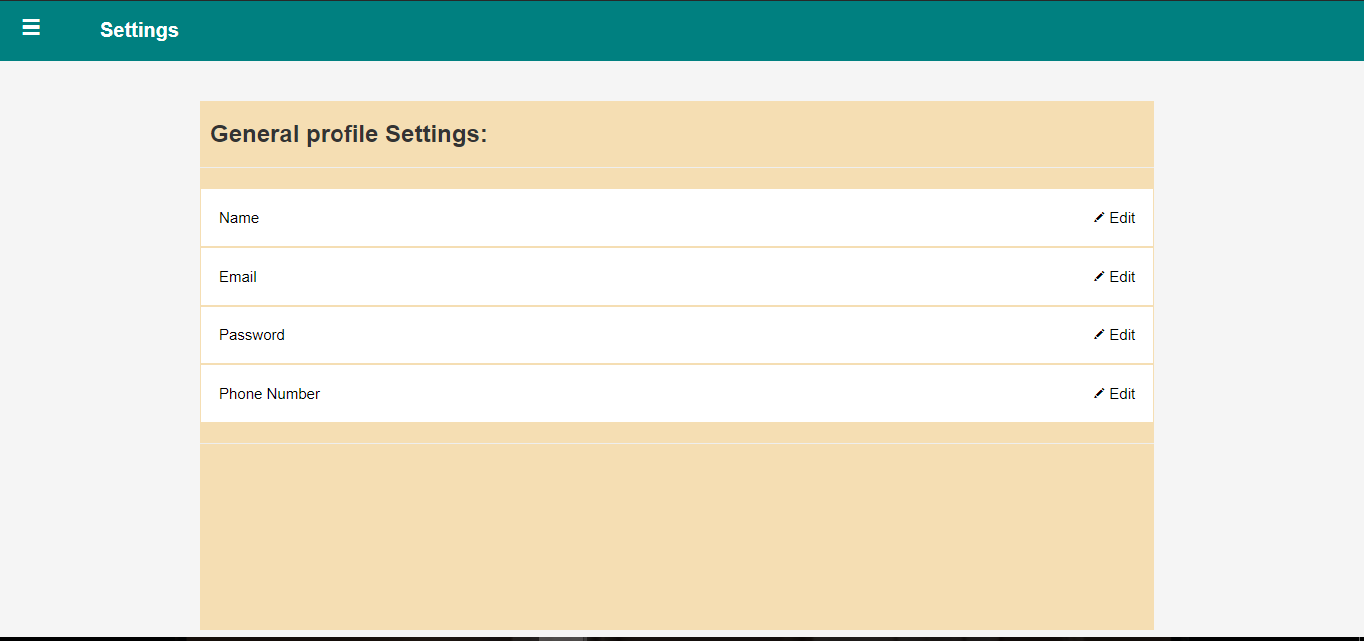

Figure 18: Profile setting

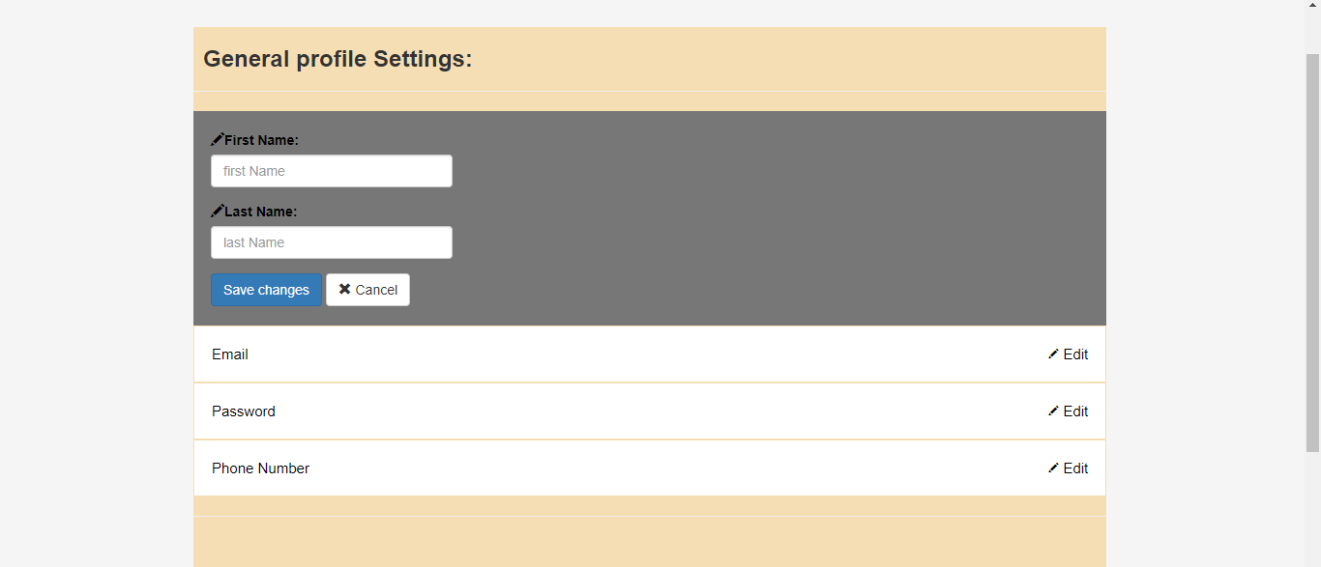

Figure 19: Change the profile name

* Classmates

Students can see post and assignment in the group. They can view the classmates using classmates’ button.

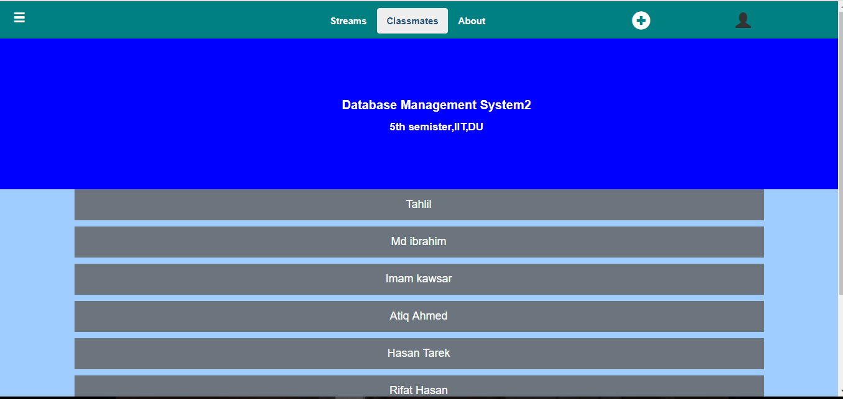

Figure 20: Classmates of student

* About

When the student click the about option s/he will view the information about the group.

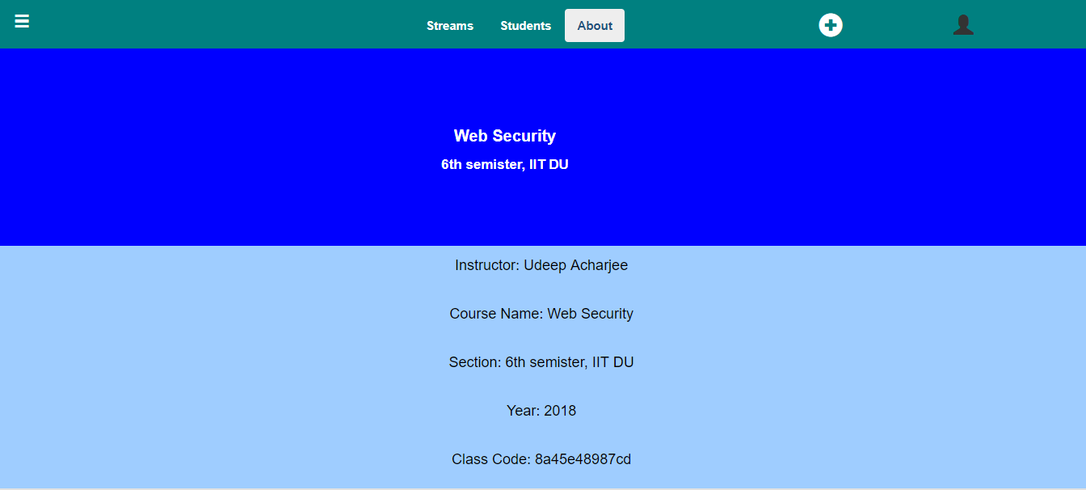

Figure 21: About page of group

* Join group

Student can join in a new group from group.

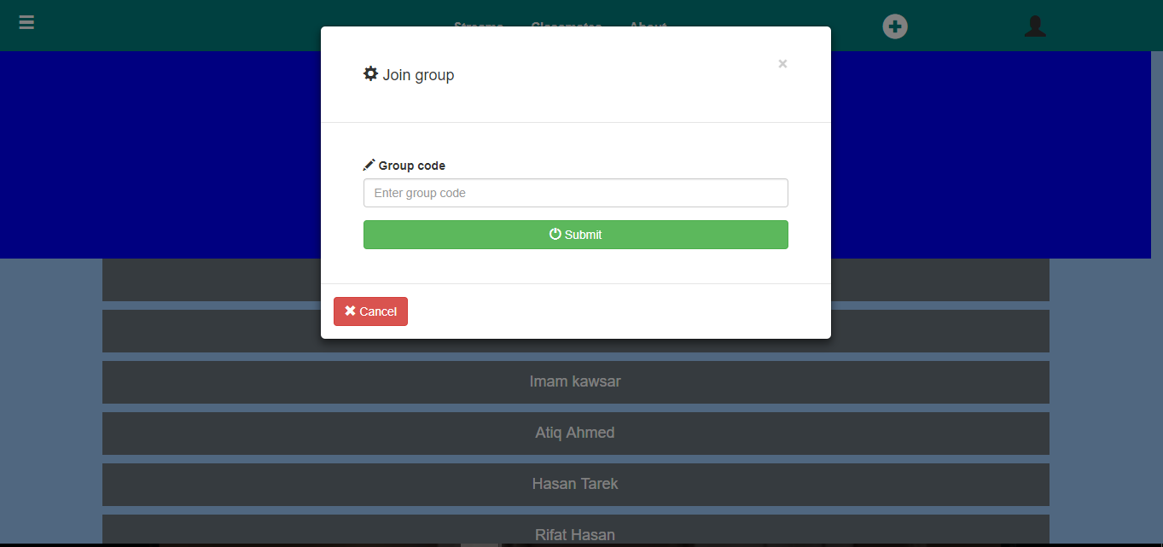

Figure 22: Joining a new group from a group

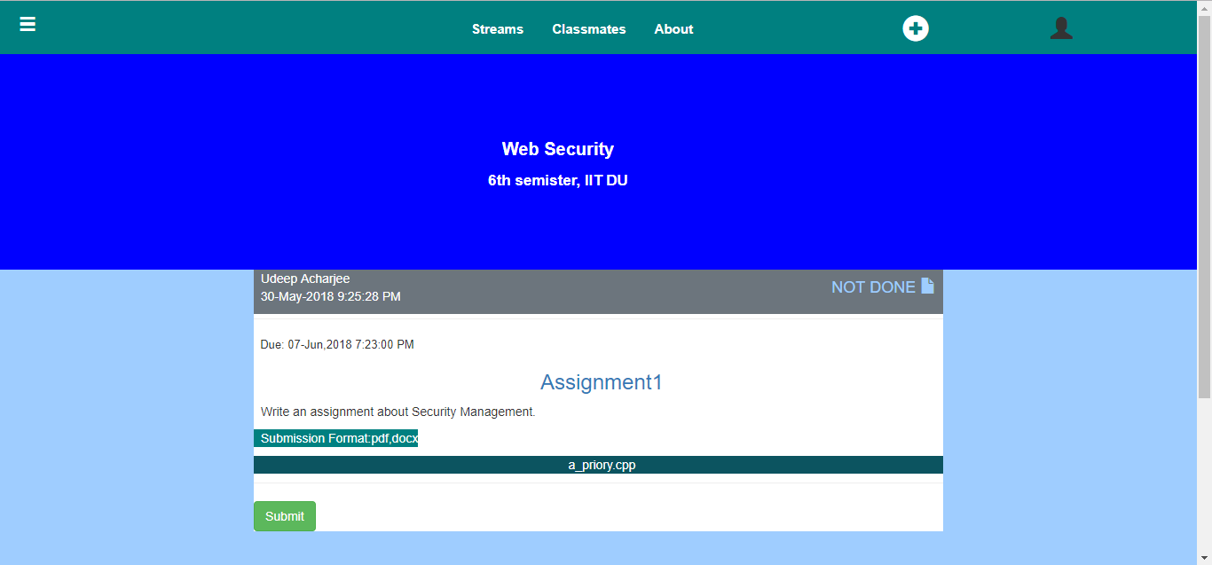

Figure 23: After joining the new group

* Submit assignment

Student can submit assignment

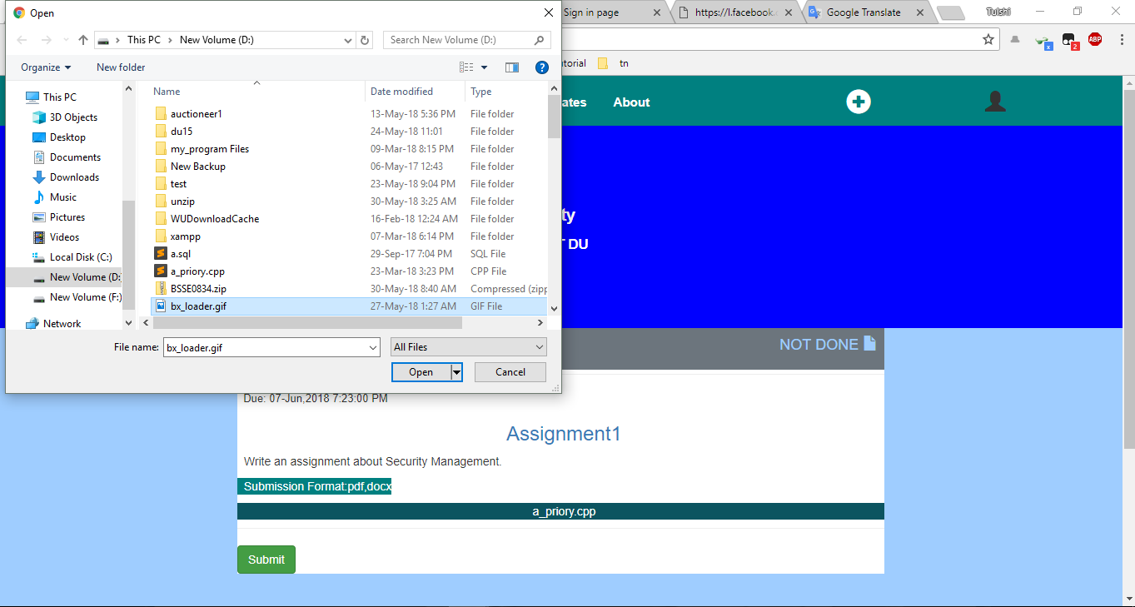

Figure 24: Trying to submit wrong file

When student submit wrong formatted file s/he will be notified an error message.

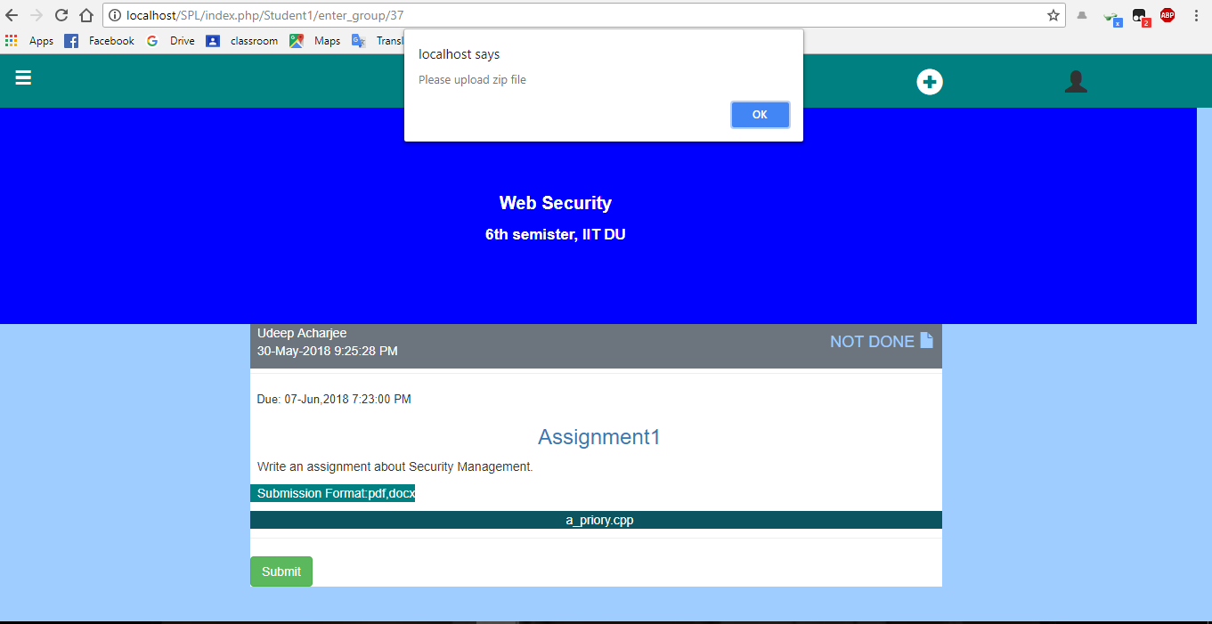

Figure 25: Wrong file submission

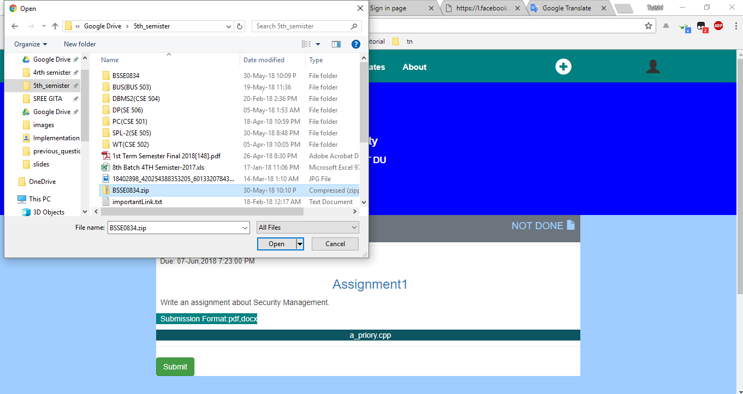

Figure 26: Selecting Zip file to submit

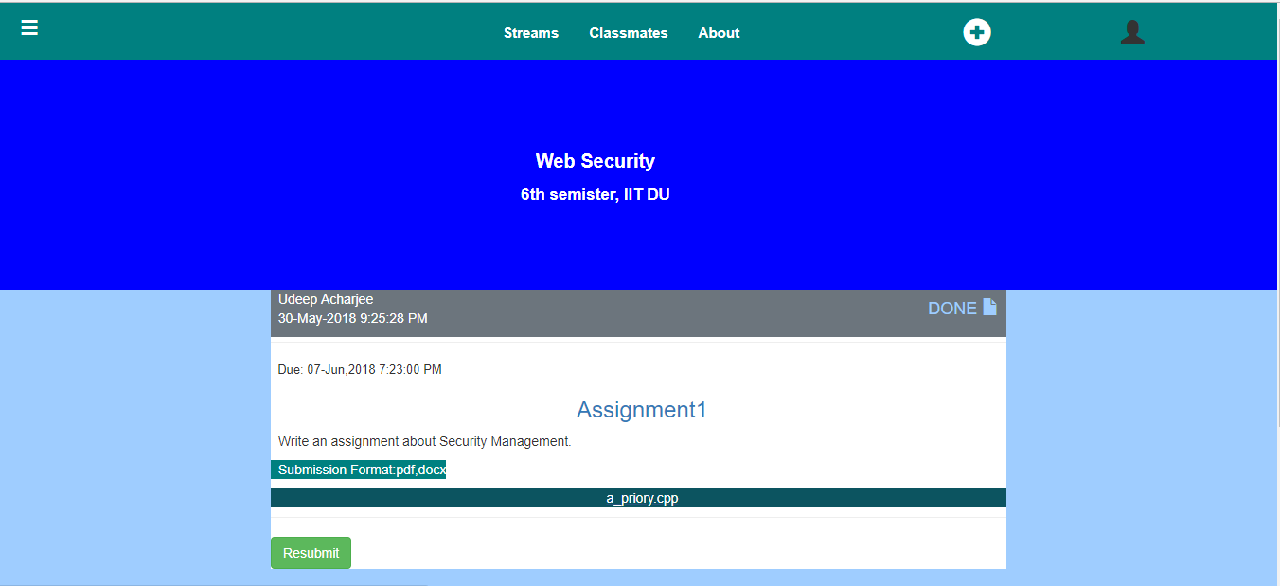

Figure 27: After right submission

* View Marks

Students can view their marks on submitted assignments choosing view marks option.

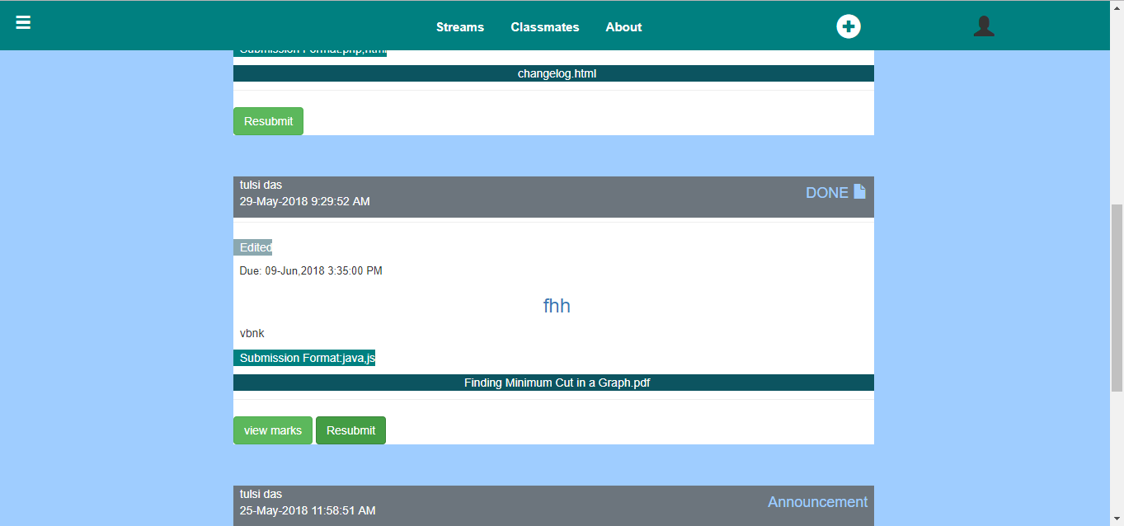

Figure 28: View mark option

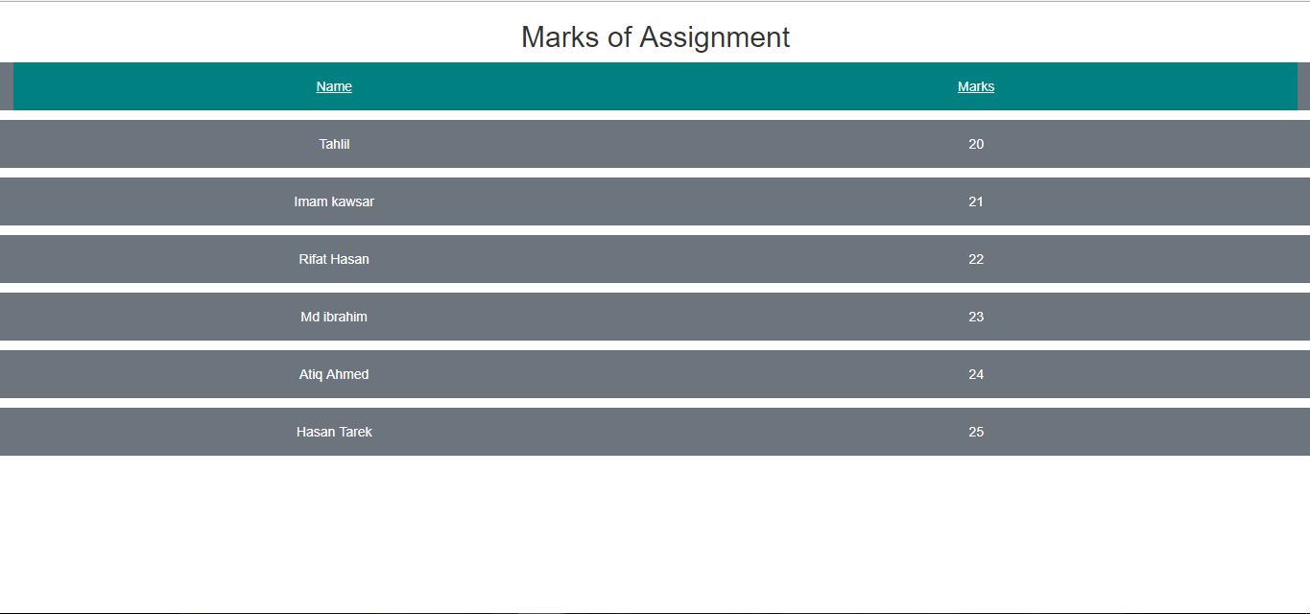

Figure 29: View marks

## 1.3 Instructor Module

### 1.3.1 Features of Instructor Module

* Menubar

In menubar button in the left side Student can see classes, calendar and settings.

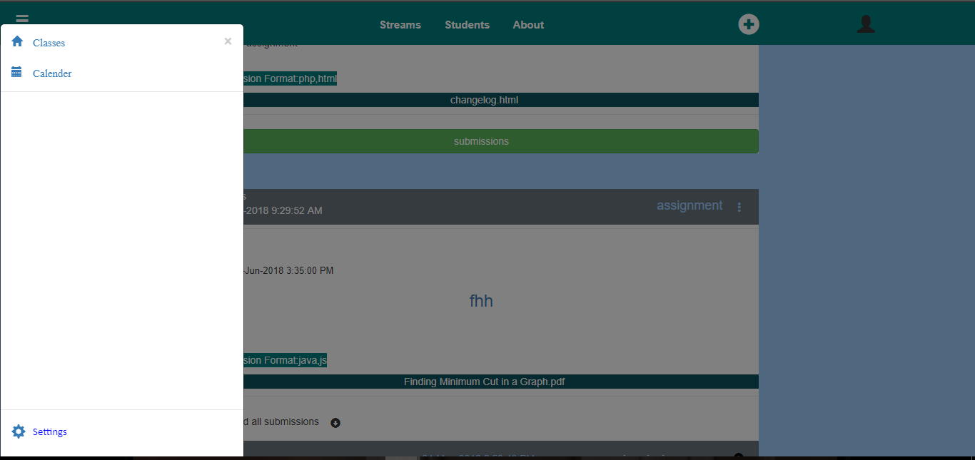

Figure 30:Menubar for Instructor

Instructor can view classes choosing classes option.

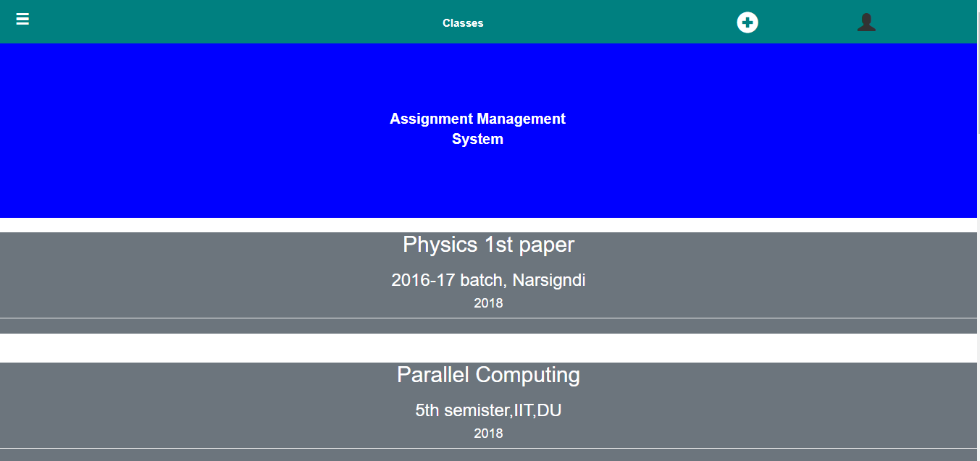

Figure 31: Group’s of teacher

Instructor can also view calendar page and settings page choosing settings or calendar option. Instructor can change his/her profile. S/he can change group name and semester name from group settings.



Figure 32:Calendar page

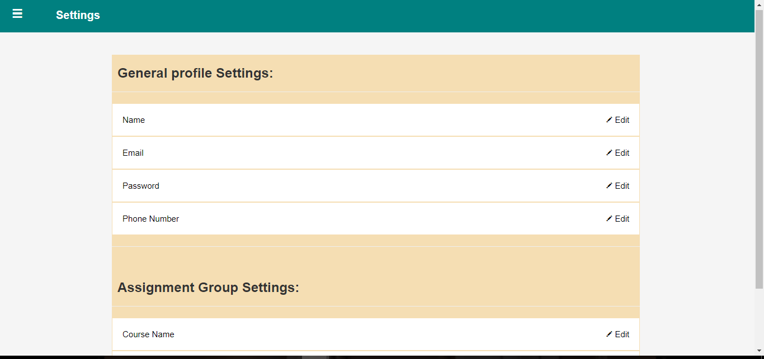

Figure 33: General profile Settings

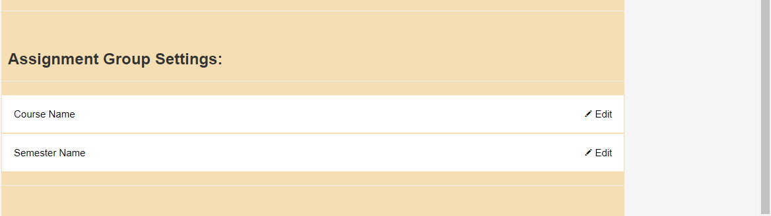

Figure 34: Assignment group settings

* Create group

Instructor can also create new group from a group using create class button or s/he can create a group when s/he first log in to the system. Above figure shows how we need to create a group after registered to the system.

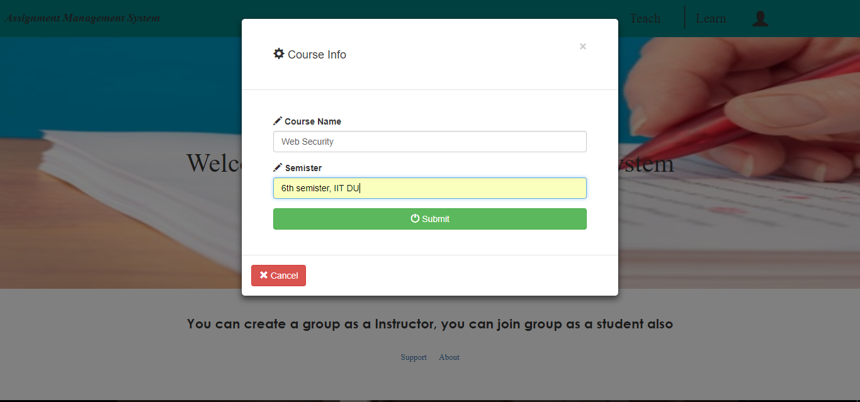

Figure 35: Entering information to create group

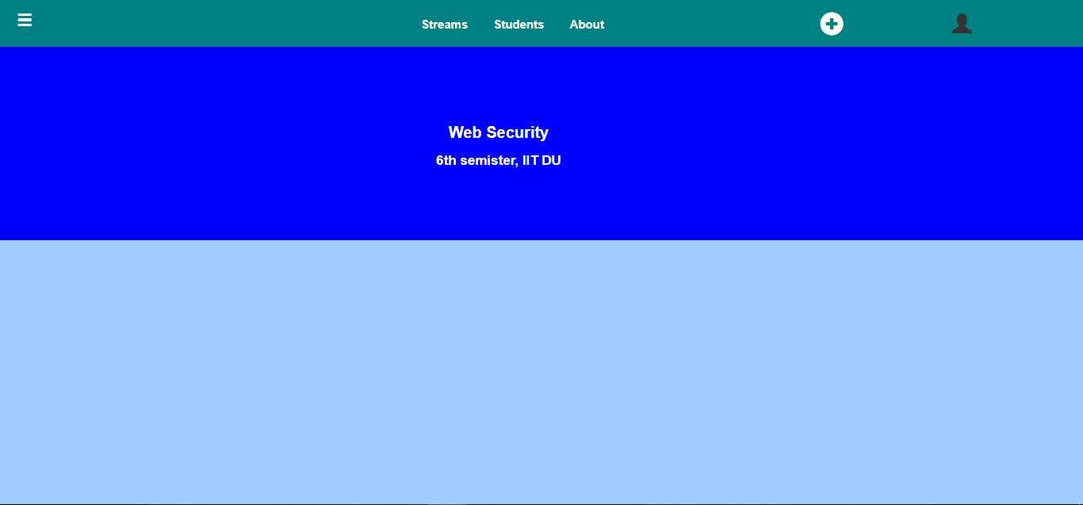

Figure 36 : Created a group

* Students

Instructor can view the students of the group selecting Students button option.

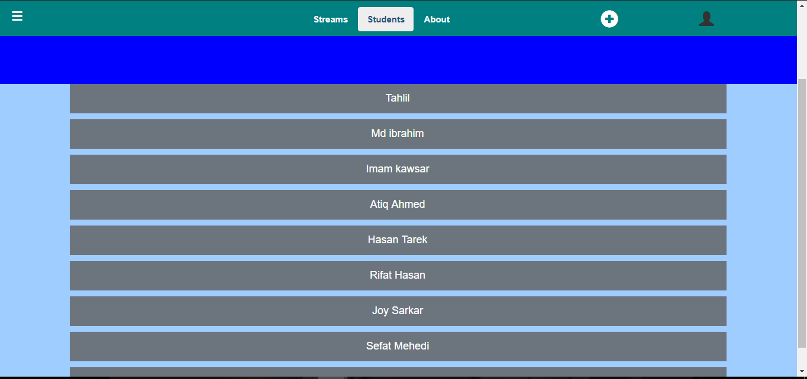

Figure 37: Group Students

* About

Instructor can view the information about the group



Figure 38: About group

* Create post

Instructor can create a post about a specific topic. Then s/he can delete it. When s/he create a post s/he can also attach a file in the post. All the students in the group can view it.

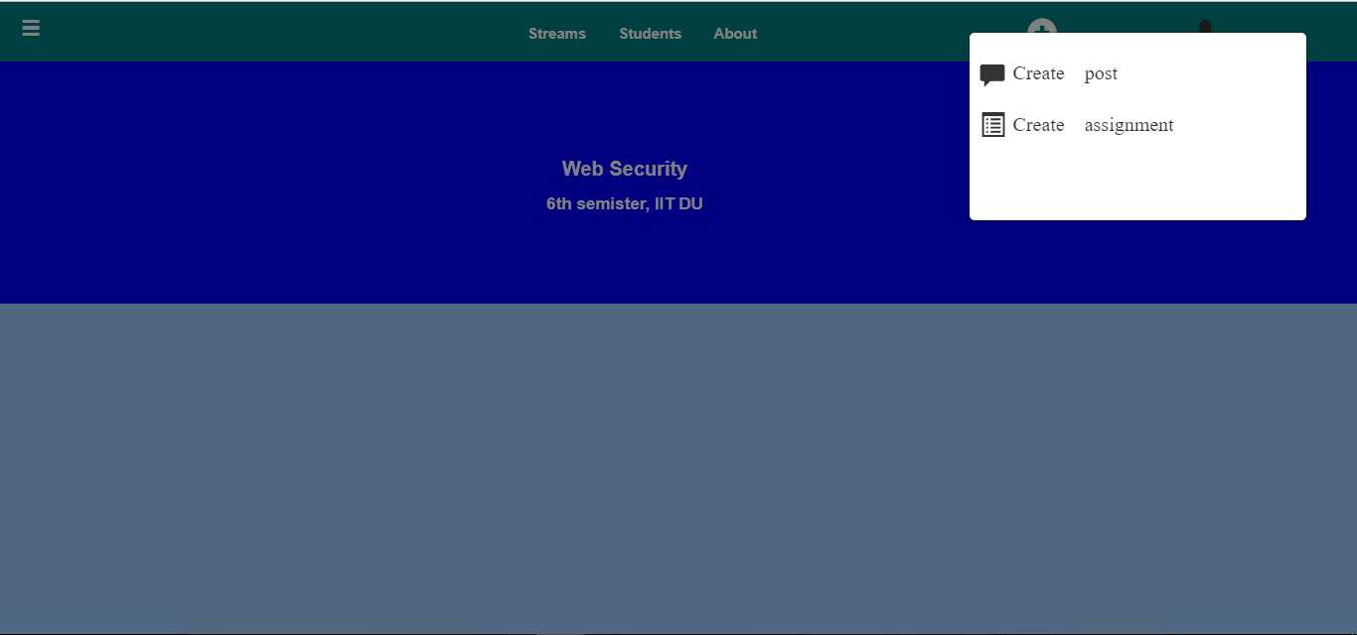

Figure 39: Post and assignment option

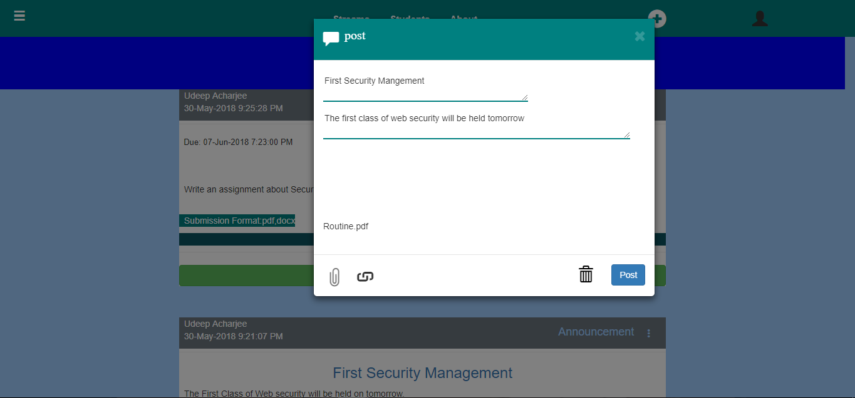

Figure 40: Enter information to post

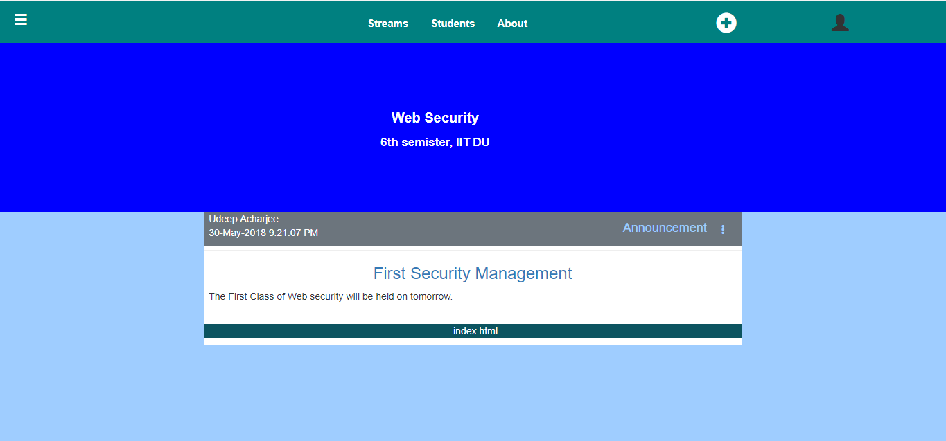

Figure 41: created post

* Assignment post

Instructor can post assignment in a group. S/he can select the format to submit the assignment

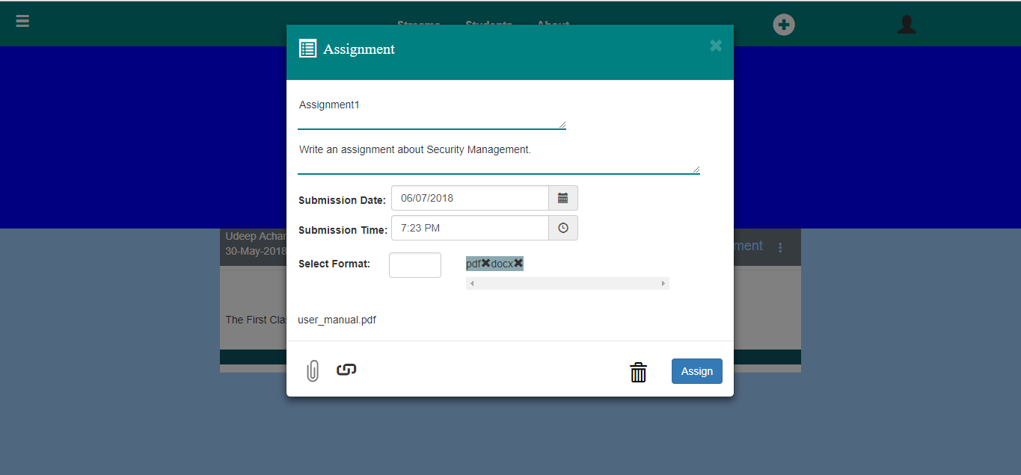

Figure 42: Creating assignment

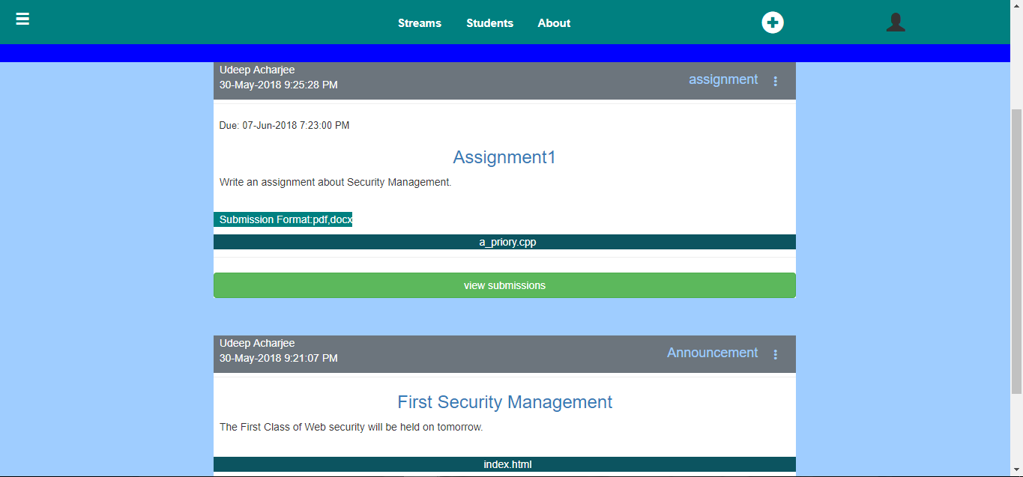

Figure 43: Created assignment

* Instructor can view how many students submitted their assignment in the group

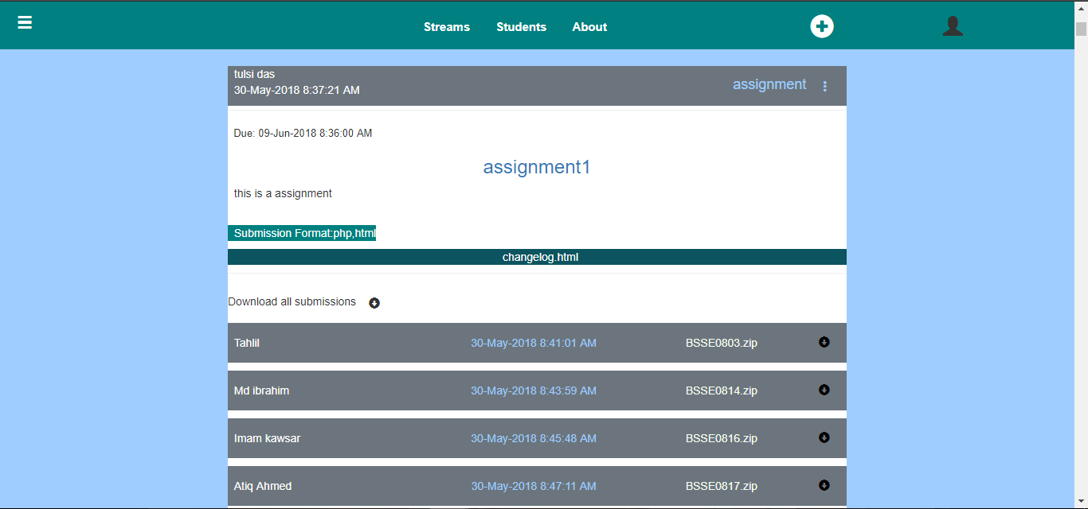

Figure 44: View submission

* Download assignment

Instructor can download all the assignment as a zip folder.

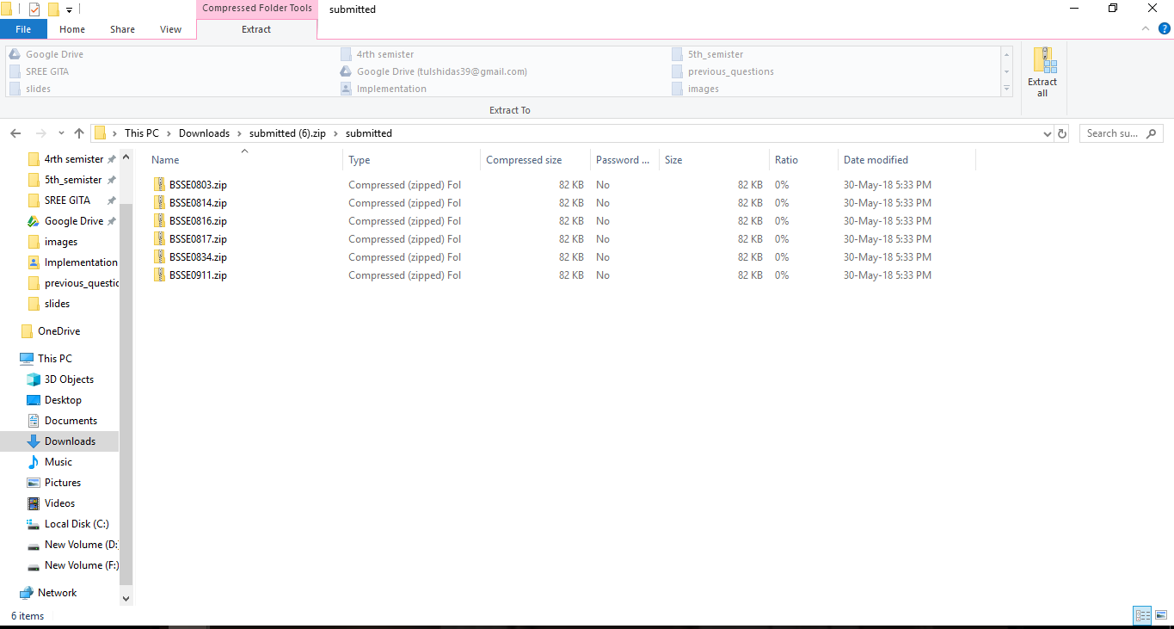

Figure 45: Download assignment

* Plagiarism checking

Instructor can check plagiarism using check plagiarism option in every assignment that was posted.

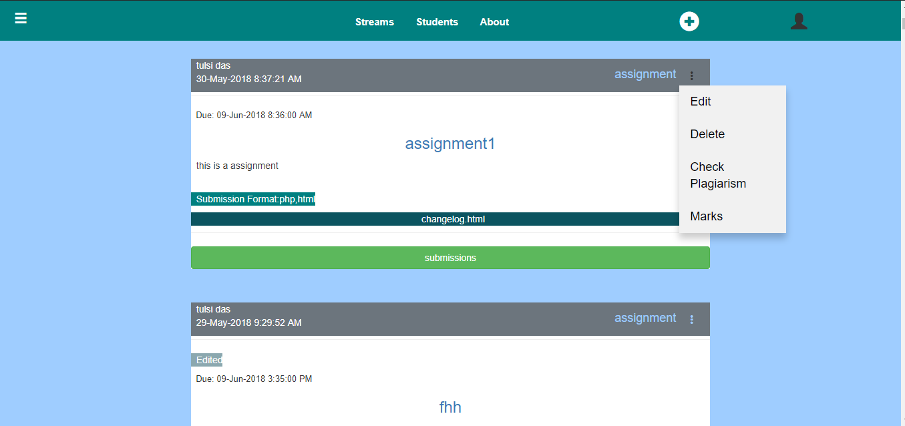

Figure 46: assignment options

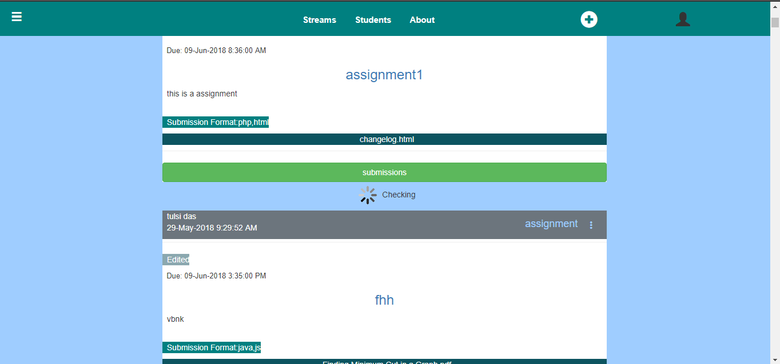

Figure 47: Checking plagiarism

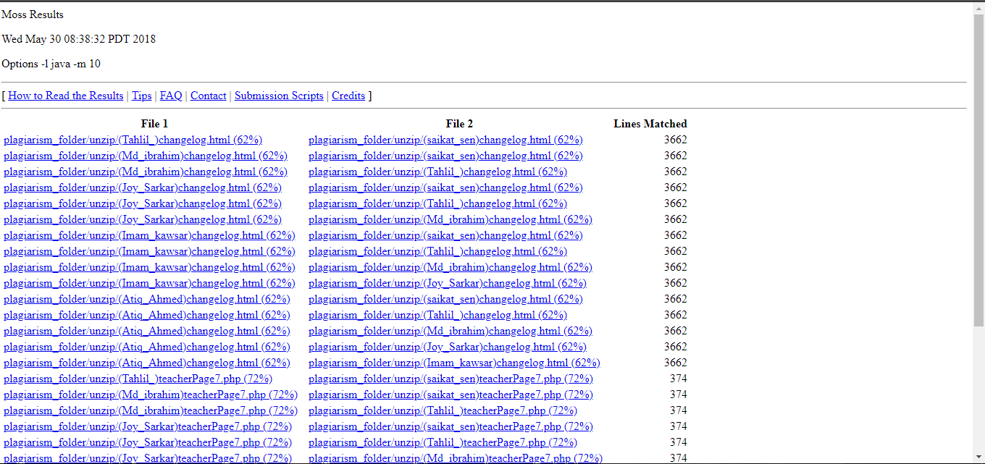

Figure 48: Plagiarism checked

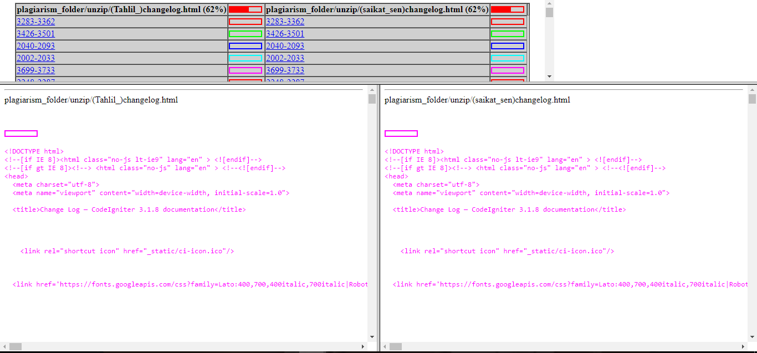

Figure 49: Check plagiarism file

* Give marks

Instructor can give marks by evaluating plagiarism of assignment.

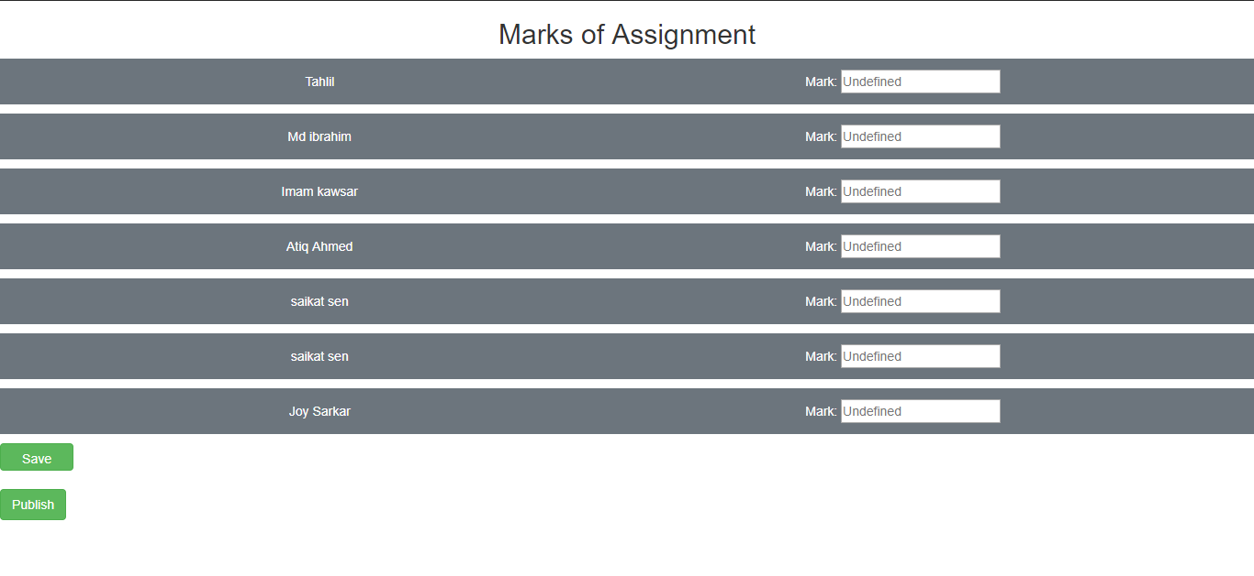

Figure 50: give Marks

‘

* Edit or Delete assignment or post

Instructor can edit or delete any post or assignment from the group

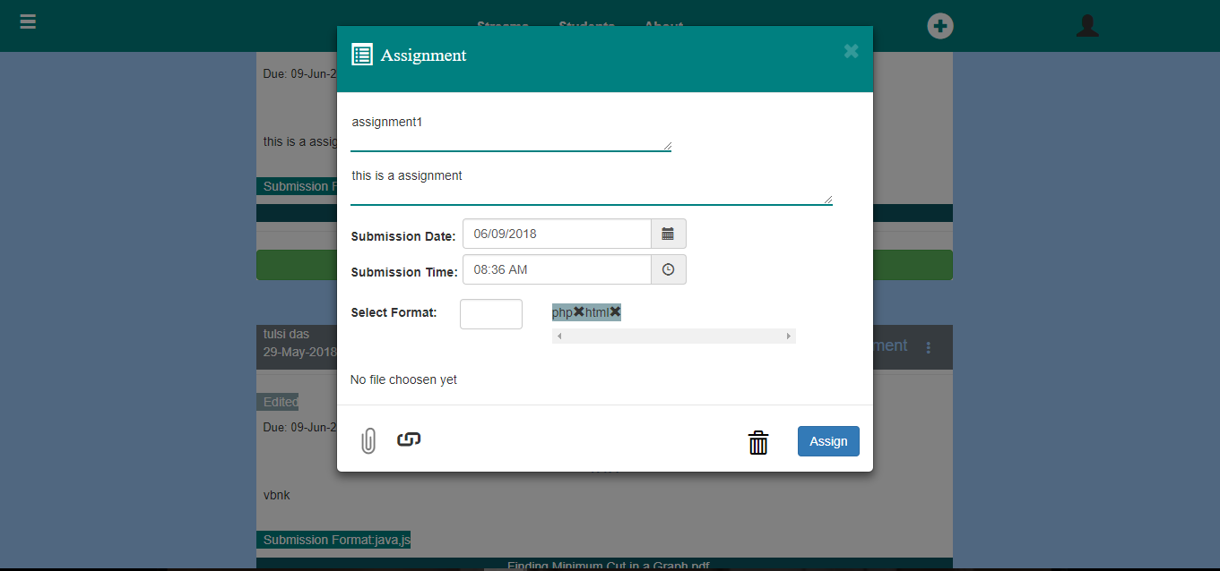

Figure 51: Edit assignment

## 1.4 Log Out module

User can log out from their groups using log out option. After log out user can view sign in page.

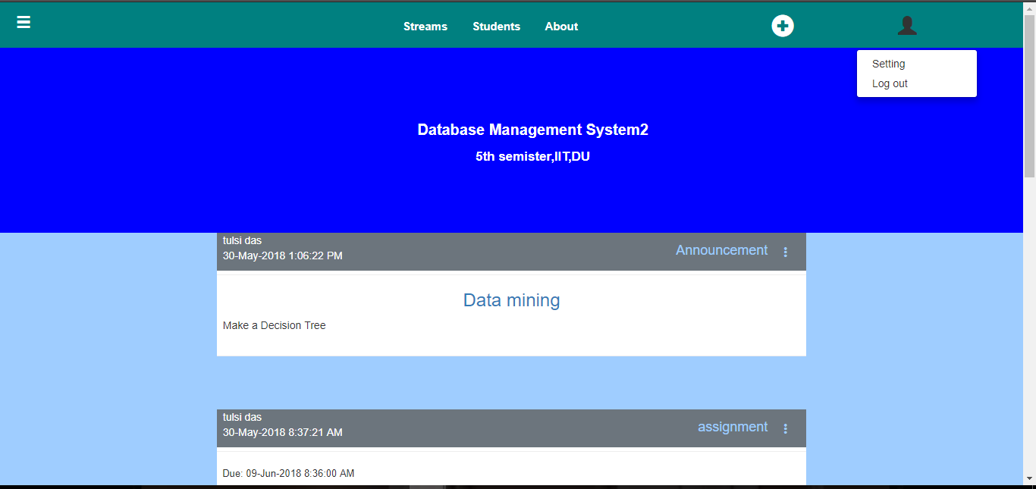

Figure 52: Log out option

## 1.5 Changed requirements

We do not allowed students to post in the group. It is our changed requirements for our system. We have done all the features defined by the supervisor. But we have canceled comment, notifications and messaging with the permission of supervisor due to insufficient of time to finish our project .